- Purpose
  - The purpose of this document is to describe the procedure for Quality Control personnel to set the down pressure switches on the GeneSys Mid-Size Machines.
- Scope
  - This procedure is applicable to all Quality Control team members who perform quality control procedures on Betco equipment.
- Responsibilities
  - Quality Control Manager-Equipment: Establish a quality control program.
  - Quality Technician: Conduct Quality Control checks in accordance with the QC Program.
- Materials
  - The proper tools, pad drivers and scale are available to the QC personnel.
- Definitions

- Procedure for Setting Down Pressure Switch Cams
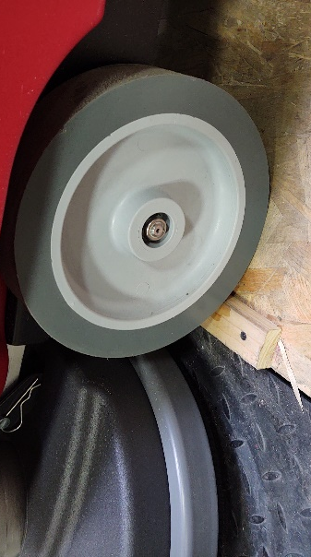
  - Move the completed GeneSys Mid-Size Scrubber machine to the top of the down pressure switch setting station with the scale. Position the machine centered on the deck near the edge of the scale.
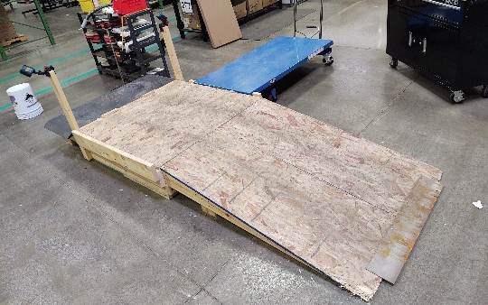
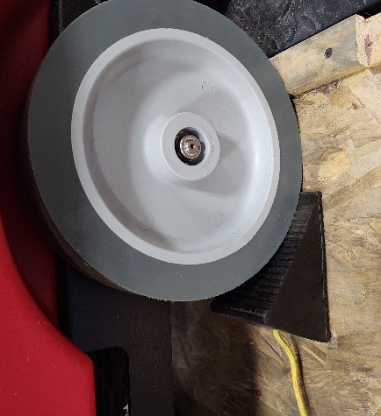
  - One wheel must be chocked to hold the machine in position.

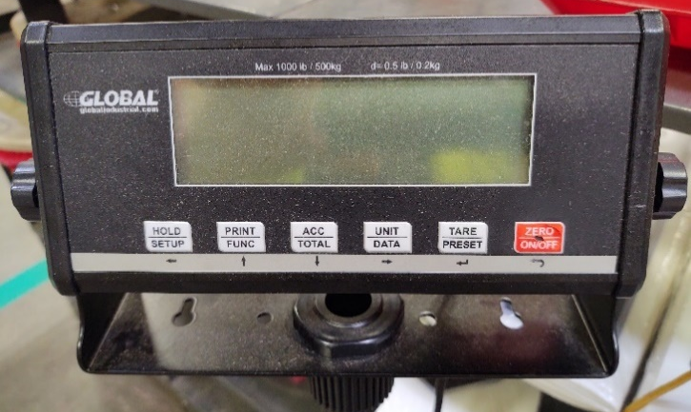
  - Turn the scale on by holding the “ON” button for 3 seconds.

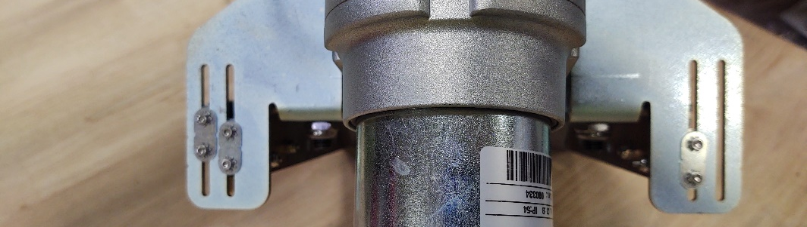
  - Place the cams in the pre-set position as shown. Only tighten one of the cam plate bolts on the three cams.

  - Select the correct pad drivers, per deck size, and slide them under the deck of the machine. If the machine is an orbital deck then install the rectangular pad onto the driver plate with ½” offset as shown in the righthand picture below.
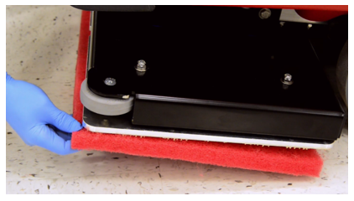
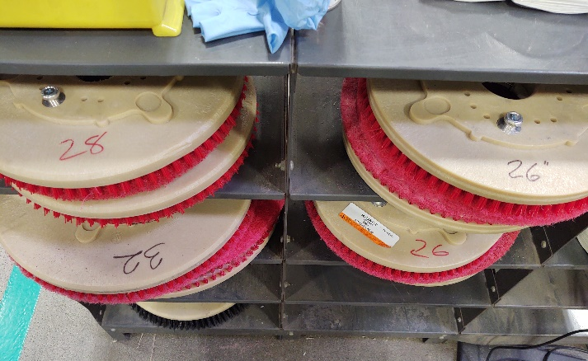

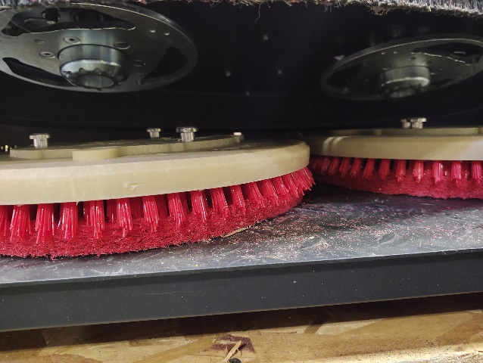
  - Lift the pad driver up and align the pad driver hub with the pad driver.

  - While lifting the left pad driver spin it “counter clockwise” to lock into place. It should click. Repeat for the right pad driver but spin it “clockwise” to lock it into place.
  - Lower the scrub deck onto the scale by turning the down pressure switch to position one.
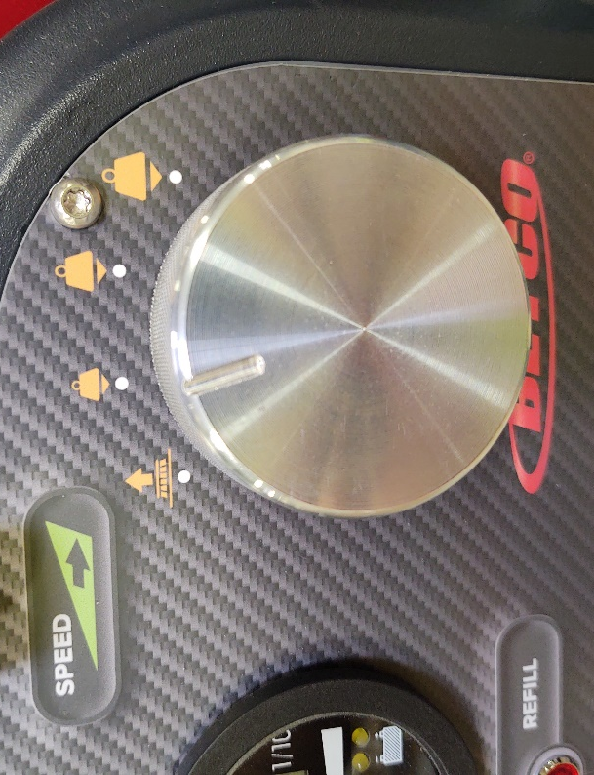
  - Make sure the scale still turned on. The first down pressure should be 60 lbs. plus or minus 10 pounds.

  - If the down pressure is not within the 60 pound target the cam for number one down pressure switch must be moved. If the pressure is too high move the cam and plate up 1/8” and recheck. If the pressure is to low move the cam and plate down 1/8” and recheck.
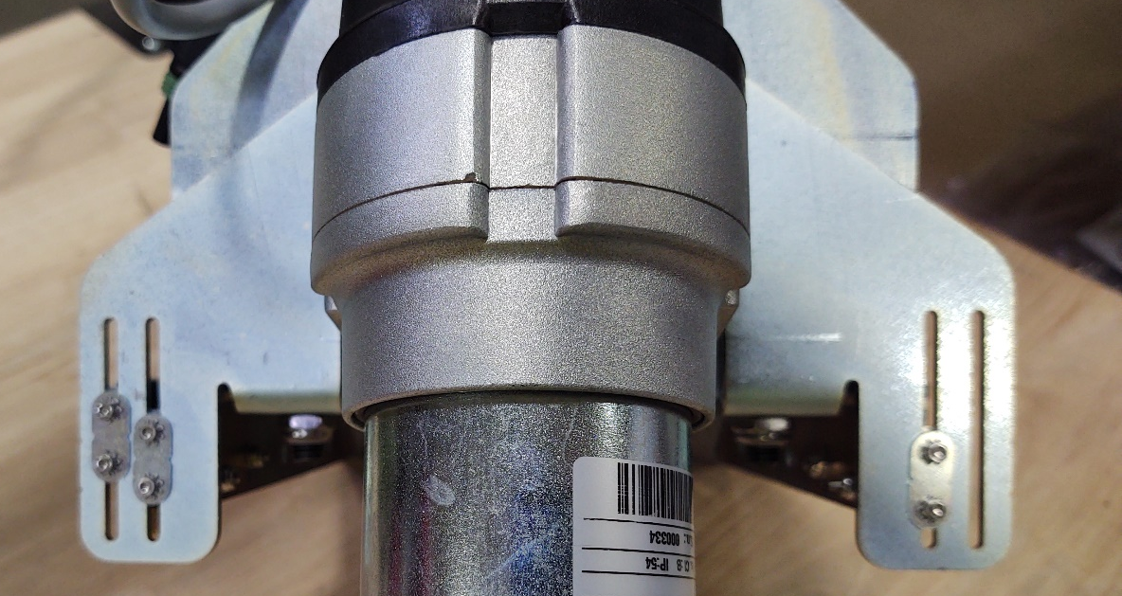
Down Pressure Cam
Plate number 3.
Down Pressure Cam Plate number 2.
Down Pressure
Cam Plate number 1.

  - Readjust the cam as necessary until the proper down pressure is reached.
  - When down pressure 1 is set at or near 60 lbs. (55-65lbs) tighten both screws on the cam plate.
  - Repeat the process for down pressure #2 120 lb. (115-125 lbs.) and down pressure #3 180 lb. (175-185 lbs.).
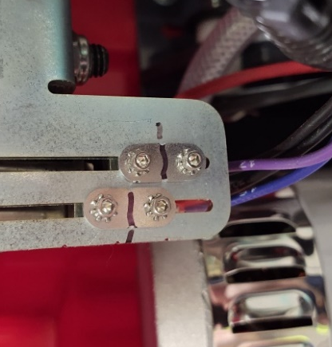
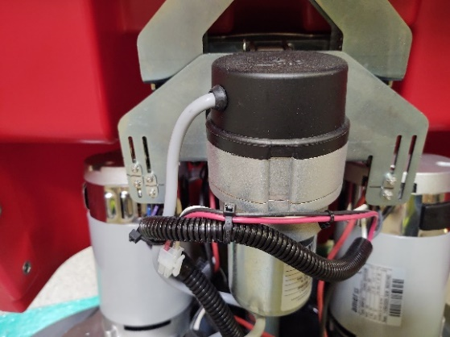
  - When all the down pressure switches are set correctly mark the plates as shown with a permanent black marker.

**When the switches cannot be set because the cam misses the switch plunger the limit switches must be moved inward towards the cam block.
  - Put the deck down in down pressure three setting. Turn off the machine.
  - Move the cam(s) up from the bottom of the slots to approximately ¾” above.
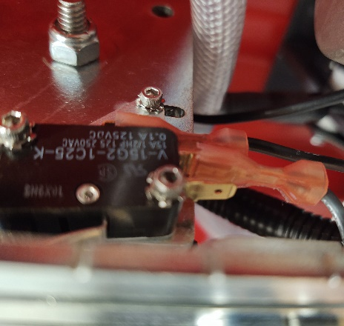
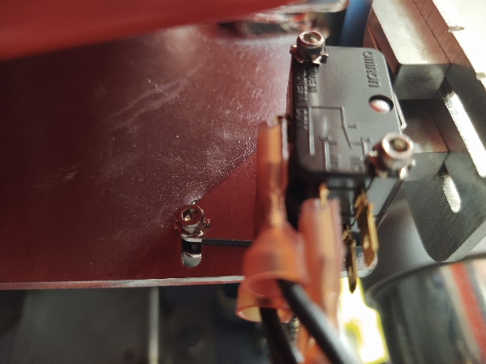
  - Loosen the three bolts with a 3/32” Allen key and ¼” wrench. Leave the circled bolt slightly snug. You want to be able to rotate the switch plate around that bolt.
Down Pressure Switch 3
Down Pressure Switches 1&2

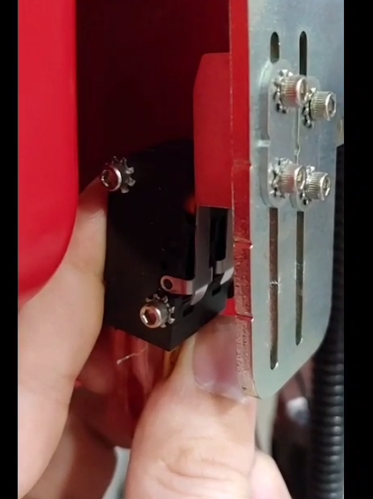
  - Slowly rotate the top of the switches towards the front of the machine until you hear a click of the limit switch. Go 1/16” further and stop.

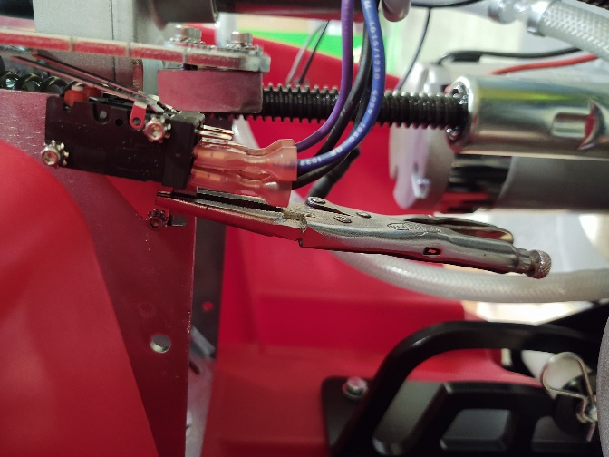
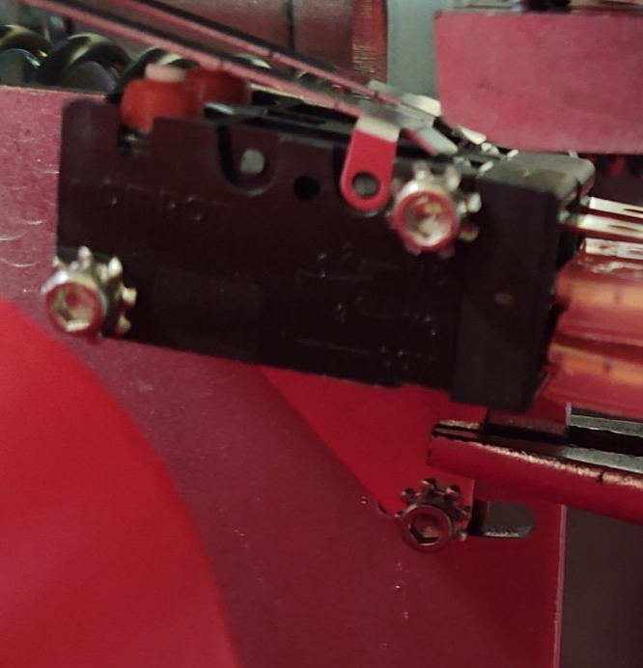
  - Use the little needle nose vise grips to hold the switch plate in position.

  - Tighten all 3 bolts using the 3/32” Allen Key and the ¼” Wrench. Remove the vise grips.
  - Turn on the machine on and raise the scrub deck all the way up to the transport position.
  - Verify the switch you just adjusted works and set the switches again per this SOP.

- References

- Training Guide

Functional Training Groups Requiring Training
Equipment Quality Control

- SOP Change Control

Date of Change | Reason for Change
Rev 01 | This is the first version of the S.O.P. hence there are no revisions to this document.
Approvals

Submitter/Author Approval:__________________________________ Date:______________________

Management Approval:______________________________________ Date:______________________

QAU Approval:_____________________________________________ Date:______________________

